
The Mixed Nuts
Set BB Last revised on 2016.05.24
BB01-Don't Be That Way(K).2014.04.26.pdf
BB02-Out Of My Dreams(KVF).2016.05.24.pdf
BB02-Out Of My Dreams(KVM).2016.05.24.pdf
BB03-Tonight(KVD).2015.05.03.pdf
BB04-Them There Eyes(KVF).2016.05.24.pdf
BB04-Them There Eyes(KVM).2016.05.24.pdf
BB05-You'll Never Walk Alone(KVD).2016.05.24.pdf
BB06-Prospector Polka(KVF).2015.05.03.pdf
BB06-Prospector Polka(KVM).2015.05.03.pdf
BB07-You Must Have Been A Beautiful Baby(KVF).2014.10.24.pdf
BB07-You Must Have Been A Beautiful Baby(KVM).2014.10.24.pdf
BB08-Yes, We Have No Bananas(KVF).2016.05.24.pdf
BB08-Yes, We Have No Bananas(KVM).2016.05.24.pdf
BB09-Evergreen(KVF).2016.05.24.pdf
BB09-Evergreen(KVM).2016.05.24.pdf
BB10-Secondhand Rose(KVF).2015.05.03.pdf
BB10-Secondhand Rose(KVM).2015.05.03.pdf
BB11-People(KVF).2016.05.24.pdf
BB11-People(KVM).2016.05.24.pdf
BB12-Pretty Baby(KVF).2016.05.24.pdf
BB12-Pretty Baby(KVM).2016.05.24.pdf
BB13-You'll Never Know(KVF).2016.05.24.pdf
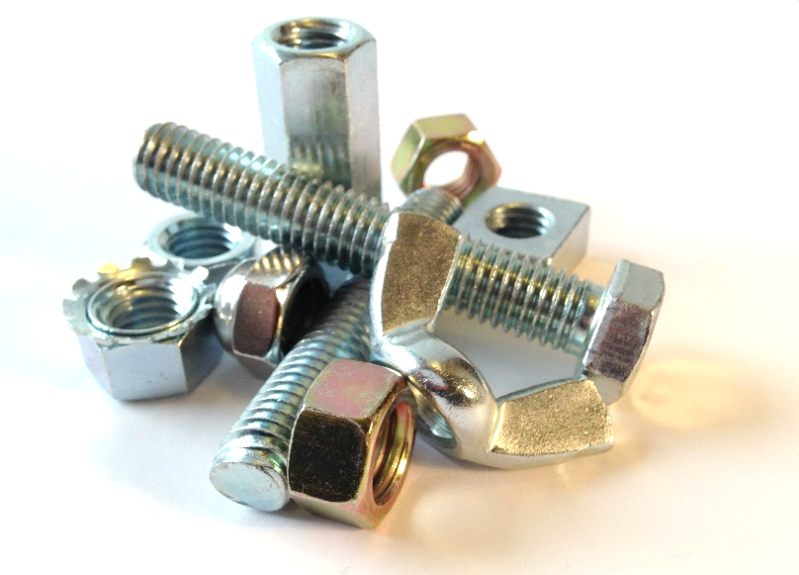
BB13-You'll Never Know(KVM).2016.05.24.pdf
BB14-Daddy(KVD).2015.04.26.pdf
BB15-Changing Partners(KVF).2016.05.24.pdf
BB15-Changing Partners(KVM).2016.05.24.pdf
BB16-The Breeze And I(K).2014.10.24.pdf
BB17-Choo Choo Ch'Boogie(KV).2014.04.19.pdf

